The meeting was called to order at 6:35 pm by Board President, Marie Onorevole.

**Sunshine Statement**: This meeting has been posted in accordance with the Open Public Meetings Act, in the officially designated newspapers and The Library.

**Roll Call:**

* Marie Onorevole, President and Alternate to the Superintendent
* Laurie Schorno, Vice President
* Ray Furman, Treasurer
* Bronwyn Springer, Secretary
* Carol Tauber, Trustee at Large (via Zoom)
* Emily Kullmann, Trustee at Large
* JoAnn Claps, Alternate to the Mayor
* Emanuel Friedlander, Council Liaison
* Scott Davan, Library Director

**Also Present:** Isabelle Avigliano

**Agenda Approval:** No changes proposed; approved as written.

**Approval of Minutes:** Motion to approve December minutes made by Ray; seconded by Marie. Laurie abstained. Motion carried.

**Treasurer’s Report:** Motion to approve bills accrued in January in the amount of $108,318.88 made by Ray; seconded by JoAnn. Motion carried.

**President’s Report**

**From the Schools:**

1.RTSD 2025- 2026 Kindergarten Registration begins on-line February 6, 2025. Parents/Guardians will pre-register and book an appointment on-line to complete registration in-person at RT Board of Education located at 16 School Road, Hibernia, NH 07842

Please refer to the flyer attached for additional information.

<https://www.rocktwp.net/article/1947534>

2. Kathryn Pietrowski - Recommended for Director of Student Services

Message from Dr. Corbett:

“I am pleased to announce that at the January 8, 2025, Board of Education meeting, I will recommend that Ms. Kathryn Pietrowski be approved as the Director of Student Services replacing Dr. Alain Mollinedo. This appointment will be effective February 17, 2025. Most recently, Ms. Pietrowski served our students as Supervisor of Special Education. We are grateful to Dr. Mollinedo for his services to the district and we look forward to working with Ms. Pietrowski as she leads this very important department. Congratulations Ms. Pietrowski!”

3.Statement from the RT Board of Education, December 20, 2024

This statement addresses issues raised by the NJ Department of Environmental Protection (NJDEP) regarding capital improvements across all district schools.

Please read the attached letter. Note: Print copies of the letter were distributed to the Library Board of Trustees.

<https://www.rocktwp.net/article/1936339>

**For the Board:**

1.The American Library Association’s Freedom to Read Statement and RT Free Public Library as a Book Sanctuary Resolution

During Old Business we will finalize our adoption of the resolution following several months of research and discussion. Draft of the Resolution has been sent as an attachment to you in an email. Print copies have been provided to the Library Trustees at this meeting.

2. Plans to consider for the 2025- 2026 year

During New Business, let’s discuss implementation of offerings from the American Red Cross for Babysitting Certification, providing opportunities for information regarding Working Papers for teens, Passport Application services provided by outside agencies, service projects for teens and adults, etc. Increasing our social outreach to the community would a great next step for our wonderful Library.

**For the Staff:**

Happy New Year to you and your loved ones!

Together as we embark on a new Strategic Plan, we are very interested in your ideas, suggestions, and feedback, implementing the RT Library’s goals and objectives. Working together we are most successful!

**Director's Report**

**State Aid application**

Application just opened – being completed on Township’s end and we have to complete our report by mid-March.

**Budget update**

I still don’t have all the figures I need to present a draft budget to the committee for review.

**Bathroom updates**

Spoke with Township’s Purchasing Agent, we don’t have to go to sealed bid for architectural services there are other ways. Investigating options, hope to have clarification by February meeting.

**Mural updates**

Got bids from two other artists, neither would do sketch without written agreement. Bids in the area of $20-$30 per square foot.

**Hibernia Painting update**

I’ve signed up for the Jan 29th grant workshop as has our grant writer. Initial date of application is due February 28th.

**Gmail update**

Working with Lisa Laskaris and MAIN to migrate our email server to Gmail. Date of transition is set for Monday, February 3rd.

**HVAC software maintenance agreement**

Received proposal for HVAC software maintenance and it’s surprisingly large. Will have to seek other vendors for additional proposals.

**Website**

Updated back end of WordPress and it nearly took down our website. Most is back in working order, calendar is problematic and the company is unresponsive. Looking at options and redesign.

**Township holding health benefits so no check required**

Beginning in January 2025 we will no longer need to send the Township a check for health insurance as they’ll withhold the amount from our disbursements. This will streamline the process for both parties.

**Paper of Record**

This month Governor Phil Murphy signed A5151 into law allowing for

“public bodies to continue using newspapers for required public notices and legal advertisements until certain specified date regardless of format.” I recommend

we chose a new newspaper of record by our March meeting. The Daily Record is still in print, we’d have to set up an account before we replace The Star Ledger.

**New items for library of things**

New items have been ordered for our Library of Things based on the usage of neighboring libraries. We have on order: a pickle ball set, travel outlet converters, bicycle repair kit, laser tag set, record player, FLIR camera, and walkie talkies.

**Spring Festival**

The Spring Festival is not far away, we’ll begin planning shortly. Any suggestions for this year’s event are welcome.

**Family Donation**

I have finalized the upcoming donation with the previously mentioned family. I’m ordering a bronze statue for the patio of children reading on a bench and the family will reimburse us. We’ll add a plaque to or near the bench in recognition of the donation. <https://timelessbronze.com/products/bronze-reading-boy-and-girl-reading-with-books-on-bench-statue?_pos=9&_sid=286a7db01&_ss=r>

**Our next meeting is Monday, February 10th at 6:30pm.**

**Department Reports:**

From: Lisa Laskaris Reference / IT Librarian

* Reference / Adult Services
  + We answered 116 reference questions in December.
  + We continued reference virtual and in person services through December 2024, along with continued services to the public (browsing, studying, groups meeting, computer time) chat, Facebook, Kanopy, Libby for access of ebooks, audiobooks, movies, magazines. We have Libby for digital magazines and newspapers. We staffed the online chat for our open hours Monday-Thursday 9:00am-8:00pm and Tuesday, Friday-Saturday 9:00am-5:00pm, Sunday 1:00pm-4:00pm, checking and responding to patron phone calls, emails, chats and texts.
  + Continuing to develop and book new in-person and virtual programs for upcoming months.
  + We booked Meeting Room requests for the upcoming months.
  + We sent out our monthly newsletter and book club newsletters.
  + Our book club met in December (off-site) and had 13 people attend.
  + Movies: Fabulous Four – 6 attended. Twisters – 5 attended. It Ends with Us – 12 attended.
* Programming
  + Adult services November programs:
    - Celtic Harp – 22 signed up, 14 attended!
    - Virtual Magical NYC Holiday – 13 signed up 178 attended!
    - Yoga Class – 5 signed up! 4 attended!
    - Virtual Writing Workshop – 12 signed up, 66 attended!
* Information Technology
  + Install TBS mobile and public printing replacing Envisionware
  + MAIN moving forward with gmail conversion keeping our domain. We did a couple test emails and will be stepping through complete conversion in January and February 2025.
  + Helped patrons with tech issues one-on-one, private classes.
  + Buying weekly ebooks and eaudiobooks from Libby/Overdrive.

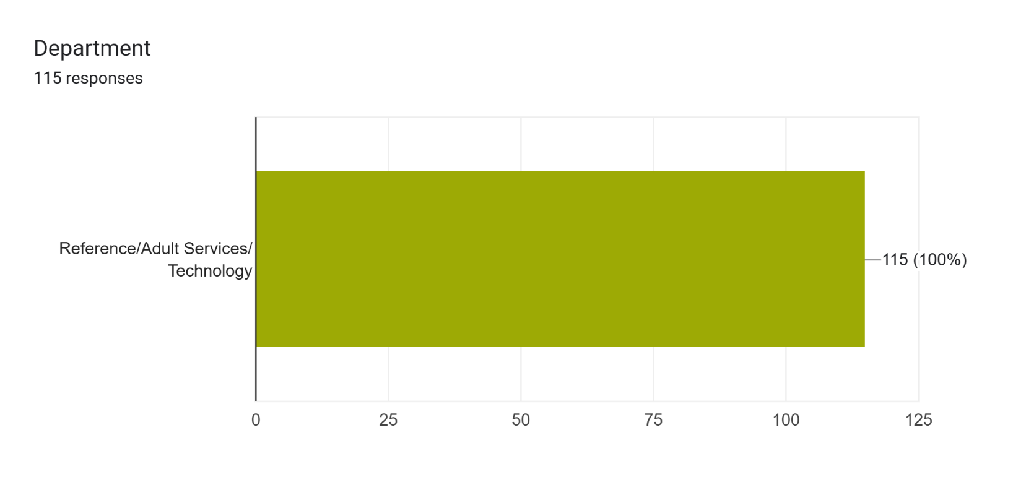

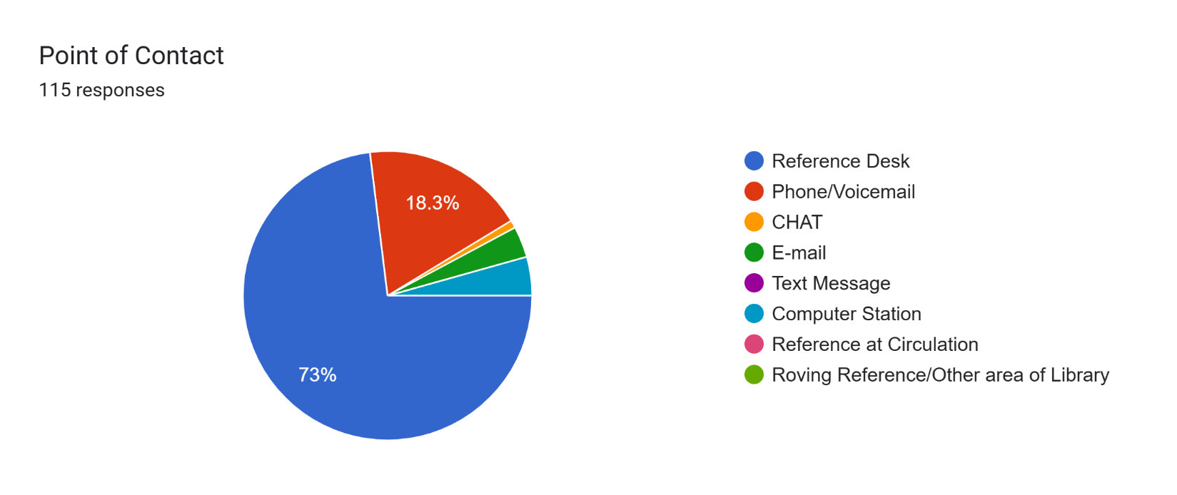

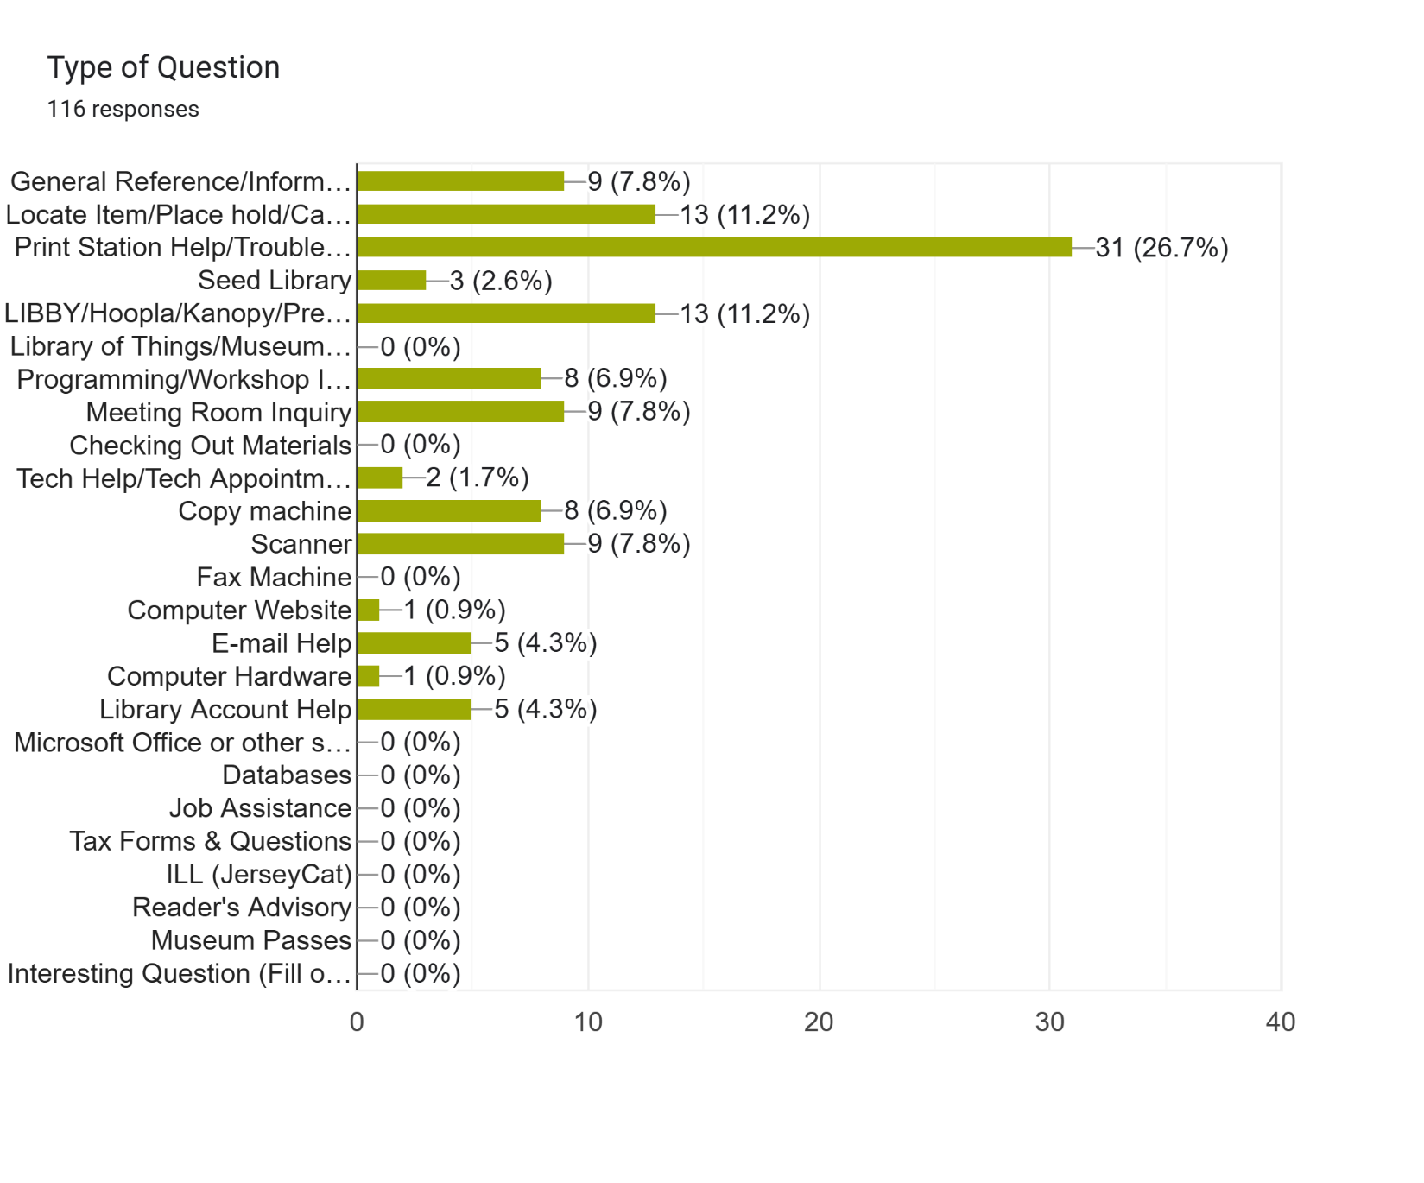

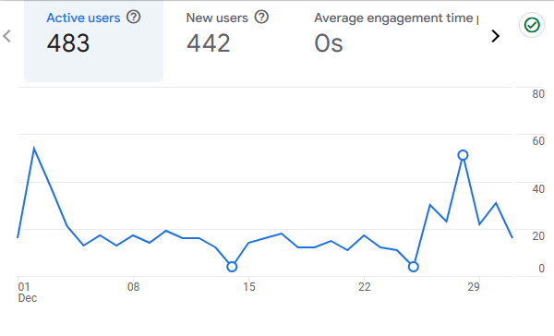

**Youth Services Report**

**Children’s Department**

**December programs for children and families included Storytimes, Babytime, and**

**Play-Doh. All were well attended. Picatinny Kindergarten returned in December**

**for a Storytime and craft. Hibernia continues to offer weekly crafts for children.**

**Over Winter Break we offered Munchkin Playtime, Crafternoons, Lego/Duplos**

**and a New Year’s Eve craft all of which drew large crowds. For grades 4-6, we**

**offered a Mario Character Drawing class. Cody resumed his Read to a Dog duties!**

**Teens**

**Teen Volunteering during the school year started in November with several**

**volunteers coming in each week to weed in childrens and teens, clean toys and**

**make bookmarks. Volunteering continues.**

**Darlene Steinhart**

**Head of Youth Services**

**Foundation Report**

The Foundation is pleased to report that to date, over $12,000 has been raised as a result of the Annual Appeal, and donations continue to come in. Dates are out for the next meeting to be scheduled. Support for the bathroom renovation and touch tables for the children’s room is now possible.

**Old Business**

**Book Sanctuary Library/Municipality:** Following months of research and discussion, the Board reviewed the final text of the proposed Resolution 25-8: Adopting the American Library Association’s Freedom to Read Statement and Declaring the Rockaway Township Free Public Library as a Book Sanctuary. Marie made a motion to accept Resolution 25-8. Ray seconded. Motion carried.

**Resolution link:** https://www.rtlibrary.org/test/blog/wp-

content/uploads/2025/02/Rockaway-Township-Public-Library-Resolution-as-

A-Book-Sanctuary-January-2025-1.docx

**Hallway Beautification Award:**  After comparing costs from other muralists, and having approved the draft drawings, Emily made the motion to approve the Hallway Beautification Award to Carmelo Sigona in the amount of $2,650 for skilled labor and $550 for Materials. Second by JoAnn. Motion approved.

**Historic Preservation Grant (Hibernia Exterior)**

1. The Board reviewed the proposal from Connolly & Hickey Historical Architects for completing a conditions assessment update to the existing Historic Preservation Plan, developing design services and preparing contract documents for the exterior restoration of the Hibernia Public Library. The cost for Design Services is $17,200. Marie made a motion to approve the contract with Connolly and Hickey. Ray seconded. Motion approved.
2. The Board also reviewed the proposal by experienced grant writer Christy Williams to write the Morris County Historic Preservation Trust Fund 2025 Grant in order to secure the funds needed to complete the preservation project. The proposed time to complete this task is 30-40 hours at a rate of $45.00 an hour.

Non-negotiable deadlines of 2/28/25 for the Declaration of Intent and 3/28/25 for Final Application Submission are clearly delineated in the contract. Motion to approve the proposal for Chirsty Williams to undertake this work was made by Laurie; seconded by Marie. Motion approved.

**New Business**

**Bathroom Remodeling Committee** The Committee will meet in February.

**Half Day Training 3/20** Scott requested the Library close for half a day to undertake ILS Training for the staff in the use of the new circulation/loan system. The motion to close the Library on 3/20 for staff training was made by JoAnn; seconded by Marie. Motion approved.

**Outreach**  Marie discussed the need to build engagement with our teen patrons. She proposed we offer more programming for this vital age group, and suggested the American Red Cross Teen Babysitting Certification and a Working Papers Filing Workshop, neither of which would be onerous to plan and are of great interest to young people. Other ideas put forth include: Karaoke; Game Night or Unplugged Night; surveying teens as to what they would like; and expanding social media outreach. The Board will revisit this important issue next month.

**Public Portion of the Meeting**: Isabelle wondered if there would be backlash to the Sanctuary Resolution; Marie responded that the Resolution is an addition to the policies and documents that are already in place at our library. Not only that, the Resolution is supported by the First Amendment of the United States Constitution and longstanding American Library Association’s Freedom to Read Act.

Isabelle reported that after movie showings, a patron is turning certain titles around and putting other books in front of them. She said our staff simply uncovers the books and carries on with their work.

**Board Comments**

* Ray attended the Friends of the Library Name that Tune event and had such a fun time! She encouraged us to attend future events sponsored by our amazing Friends. She also said that she heard about it through word of mouth and that if it were on our FB or other social media it might bring even bigger crowds.
* The Board thanks the Friends for all their hard work on behalf of RTPL. Upcoming events include: Millionaire Trivia on February 28 and The State of NJ vs. Shidecker. This dramatic reenactment of the infamous murder trial of 1882 will take place in the RT Municipal Court Room on Friday, April 4 from 7-9 pm.

**Adjournment** Motion to adjourn made by Marie; seconded by Bronwyn. Motion carried. Meeting adjourned at 7:30 pm.

**Date of Next Meeting:** Monday, February 10 at 6:30 pm

Respectfully submitted,

*Bronwyn Springer*

Secretary