The meeting was called to order at 6:32 pm by Board President, Marie Onorevole.

**Sunshine Statement**: This meeting has been posted in accordance with the Open Public Meetings Act, in the officially designated newspapers and The Library.

**Roll Call:**

* Marie Onorevole, President and Alternate to the Superintendent
* Laurie Schorno, Vice President
* Ray Furman, Treasurer
* Bronwyn Springer, Secretary
* Carol Tauber, Trustee at Large (via Zoom)
* Emily Kullmann, Trustee at Large
* JoAnn Claps, Alternate to the Mayor
* Emanuel Friedlander, Council Liaison
* Scott Davan, Library Director

**Also Present:** Isabelle Avigliano

**Agenda Approval:** The revised agenda amended to include the NJ Library Trustee Membership Agreement and the Tonie Player Borrowing Agreement under New Business was approved as written.

**Approval of Minutes:**

1. Motion to approve Reorganization Minutes (1/27/25) made by Marie; seconded by Ray. Motion carried.
2. Motion to approve January minutes made by Marie; seconded by JoAnn. Motion carried.

**Treasurer’s Report:** Motion to approve bills accrued in February in the amount of $85,076.49 made by Ray; seconded by Bronwyn. Motion carried.

**President’s Report**

**From the Schools:**

1. Education Matters Volume 5 January 24, 2025

Updates from Dept of Human Services, Superintendent’s Office, Dept. of Curriculum and Instruction, Dept of Student Services, and each of 6 schools.

Print copy provided to the Trustees, Director, and the Public.

<https://core-docs.s3.us-east-1.amazonaws.com/documents/asset/uploaded_file/1490/Rockaway/5233592/24-25__RTSD_Newsletter_V5_1.24.pdf>

1. Announcement from the office of the Superintendent, Dr. Corbett:

New Assistant Director of Student Services

“Ms. Rebecca Garcia is our newly appointed Assistant Director of Student Services and will begin her tenure at the Rockaway Township Public Schools, on or before March 23, 2025. She has spent the last three years serving as Director of Special Education at Rochelle Park School District and brings a wealth of knowledge with special attention to managing student behavior, supporting child study teams, and is an expert in grants and reporting requirements. Welcome Ms. Garcia!”

1. Board/District Goals 2024-2025 School Year (Revised PDF January 23, 2025)

<https://core-docs.s3.us-east-1.amazonaws.com/documents/asset/uploaded_file/1490/Rockaway/5064694/Board_District_Goals_2024_-2025._REVISED.pdf>

**For the Board:**

1. The American Library Association’s Freedom to Read Statement and RT Public Library’s Book Sanctuary Resolution

We have joined the ranks of 47 municipal libraries and 4 municipalities in New Jersey!

The link to the list of libraries/municipalities and the map can be found below.

<https://www.google.com/maps/d/viewer?mid=1afAb8GoU4HXkpw4vtHSKEOp9bURa0Sg&g_ep=CAESCjExLjEyNC4xMDIYACDdYio_LDk0MjEzMTEzLDk0MjE2NDEzLDk0MjA3NTA2LDk0MjA4NTA2LDk0MjE3NTIzLDk0MjE4NjQ3LDQ3MDg0MzkzQgJVUw%3D%3D&shorturl=1&ll=40.226546004270006%2C-74.58960600000002&z=8>

Print copy provided to the Trustees, Director, and the Public.

Message from Jennie Pu, Director of Hoboken Public Library:

Dear Marie,

Such wonderful news!!! I've updated our FAQ, and map with Rockaway Township Public Library's information (if you have the resolution on your website, happy to link it).

Congratulations to the library board, director and staff for your unwavering leadership and for protecting the right to read in your community.

Warmly,

Jennie

1. During Old Business, we will continue to discuss implementation of the American Red Cross Babysitting Certification offerings, Working Papers for Teens, Passport Application Services, service projects for teens and adults, and additional community outreach opportunities.
2. Link to the New Jersey Working Papers Process

<https://nj.gov/labor/youngworkers/find-a-job/working-papers/getstarted.shtml?utm_campaign=20230505_nwsltr&utm_medium=email&utm_source=govdelivery>

Information available in English and Spanish.

Print copy provided to the Trustees, Director, and the Public.

**For the Staff:**

The Board of Trustees extends their appreciation for the dedication and enthusiasm displayed by our Staff as we all move forward with new initiatives and programming.

**Director's Report**

**Art strips**

Added to the meeting room. Two more sections to add and I’ll reach out to the schools and local artist for displaying opportunities.

* Laurie asked if the art would be for sale. Historically, there has been a sign saying “If interested in purchasing, please ask…” It was suggested that perhaps this could be run through the Friends of the Library. Will look to have a policy on this for the March meeting.

**Gallagher painting end of February**

We’re scheduled to get the hallway painted toward the end of February in anticipation of beginning the mural which I’m hoping can be started in early March. I’ve reached out to Carmelo and am waiting to hear back.

**Statue**

The statue to be donated by the Nestor family has been shipped and is set to arrive in the next few days. I’m currently in contact with the family for the creation of a plaque and once completed will invite them to join us at a Board Meeting for a proper unveiling. The statue will be secured in place; anchored to building.

**Grant Workshop**

Bronwyn, Christy Williams, and I attended the online Historic Trust Fund Grant Workshop on Wednesday, January 29th. It was a very informative workshop and there’s lots to do. Part of the grant will require us to create a 10-minute video as well as give a 15–20-minute presentation in June. Awards will be announced in July with money being disbursed in September if I remember correctly.

As part of the application, we will need a release from the Township giving us permission to pursue the work. Presently Mrs. Williams is preparing the initial documents due the end of this month and Bronwyn has approached a few residents she knows who love the Hibernia Branch to be interviewed as part of our video.

* Marie asked if Sarah would film the video. Scott will check with her. She also suggested that we try to include student patrons in the video as our 4th grade curriculum includes the history of Rockaway Township and NJ.

**Draft Budget**The draft 2025 budget has been sent to committee and should be issued to the full Board for review and approval in March.

**Red Cross Babysitting Workshop**Darlene Steinhart has been in touch with the Red Cross regarding the babysitting certification workshop. The workshop costs $1,123 for 8 teens plus an additional $106 per person thereafter. It’s a 7 ½ hour course that does not included CPR. We will be requiring interested parties to present a fully refundable (upon completion of the course) $50 deposit to reserve their spots. Once the date is confirmed we’ll begin advertising this workshop.

Additionally at the suggestion of a Trustee, and finding similar programs presented at other Libraries, I’ve asked Darlene to investigate setting up a Pokémon Club.

**Contacted Clerk about Passport Days**I’ve left two messages at the County Clerk’s office regarding hosting a Passport Day at the Library, but they’ve never called back.

**Notary**

Lisa L, Rachel, Leanne, Barbara G, and Kathleen have all expressed interest in becoming Notaries. I’ve sent everyone links to becoming a Notary and asked everyone to get the ball rolling as I’d like to begin offering the service as soon as April. To my knowledge Lisa has completed the course work, passed the test, and has sent in the application to the state. Rachel is a notary at Roxbury and needs to renew soon but is only allowed one journal which is kept at Roxbury. We need to see what can be done. I need to follow up with the rest of the group to see where they’re at.

* **The Spring Festival** dates have just been finalized. The Festival will be held on Sunday, April 27 with a rain date of Sunday, May 4. Scott has begun organizing and contacting vendors, performers and civic organizations. Brian Adams of the Rockaway Township Education Association has confirmed their participation. We are planning for the Festival to be bigger and better than ever before!

**Department Reports:**

Adult Services Report

From: Lisa Laskaris Reference / IT Librarian

* Reference / Adult Services
  + We answered 78 reference questions in January (note: half of our questions were incorrectly logged and not included in the totals).
  + We continued reference virtual and in person services through January 2025, along with continued services to the public (browsing, studying, groups meeting, computer time) chat, Facebook, Kanopy, Libby for access of eBooks, audiobooks, movies, magazines. We have Libby for digital magazines and newspapers. We staffed the online chat for our open hours Monday-Thursday 9:00am-8:00pm and Tuesday, Friday-Saturday 9:00am-5:00pm, Sunday 1:00pm-4:00pm, checking and responding to patron phone calls, emails, chats and texts.
  + Continuing to develop and book new in-person and virtual programs for upcoming months.
  + We booked Meeting Room requests for the upcoming months.
  + We sent out our monthly newsletter and book club newsletters.
  + Our book club met in January and had 14 people attend.
  + Movies: It Ends With Us – 12 attended. Reagan – 4 attended.
* Programming
  + Adult services January programs:
    - MAIN-wide Virtual Nazi Looted Art – 17 signed up, 278 attended!
    - MAIN-wide Virtual North Jersey Civil War Round Table (they host and open this program to their group and many libraries in the area)– 9 signed up 117 attended!
    - Maple Sugaring with Somerset County Parks Commission – 5 signed up! 4 attended!
* Information Technology
  + MAIN still working on Gmail conversion, keeping our domain. We did a couple test emails and will be stepping through complete conversion in February 2025. Staff trained for the change.
  + Helped patrons with tech issues one-on-one, private classes.
  + Buying weekly eBooks and eAudiobooks from Libby/Overdrive.

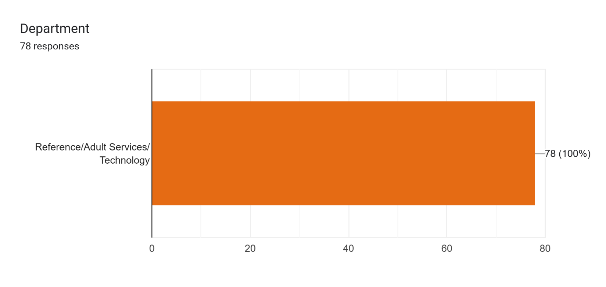

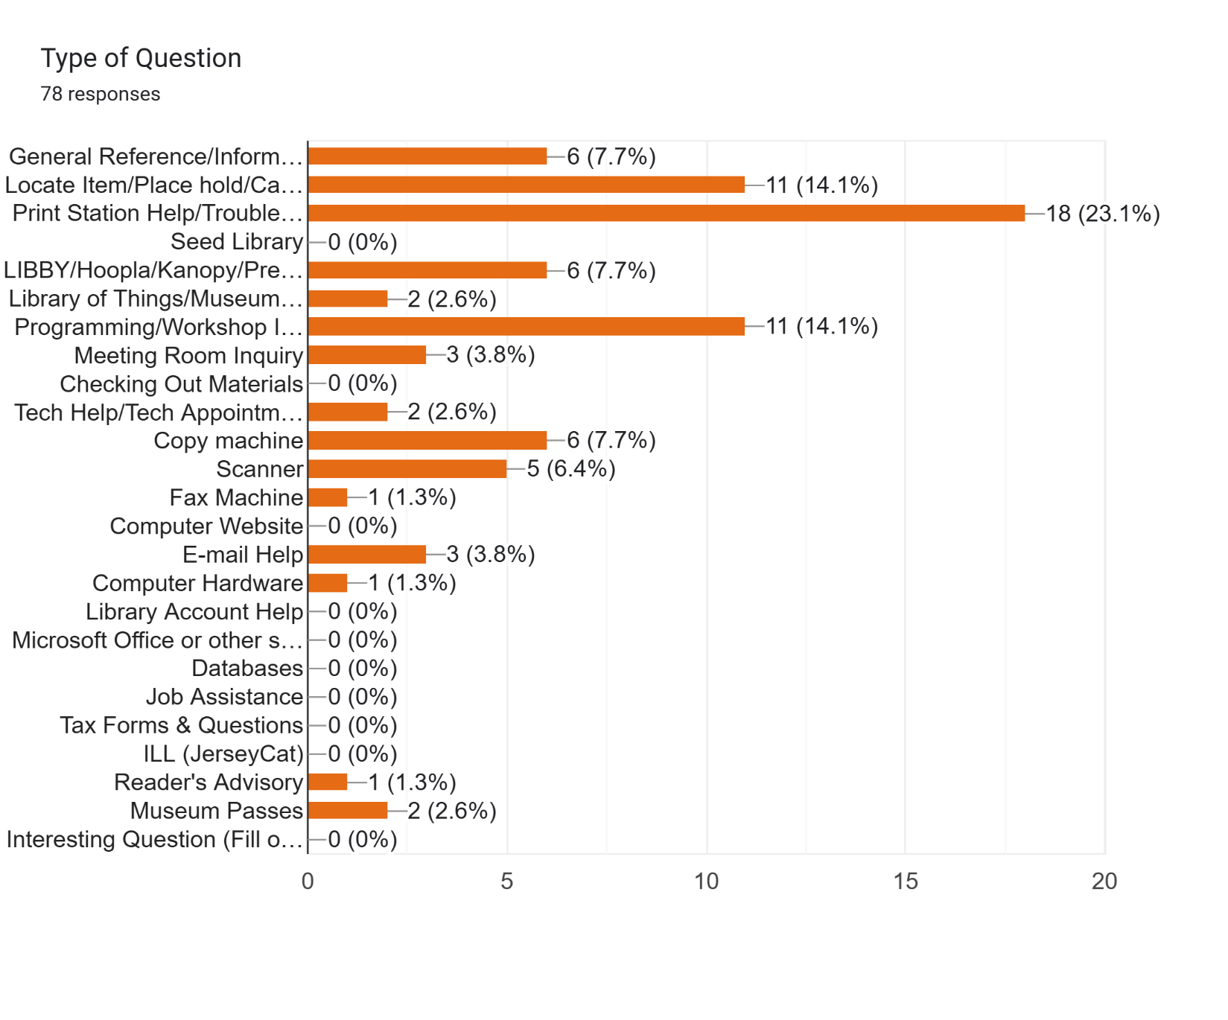

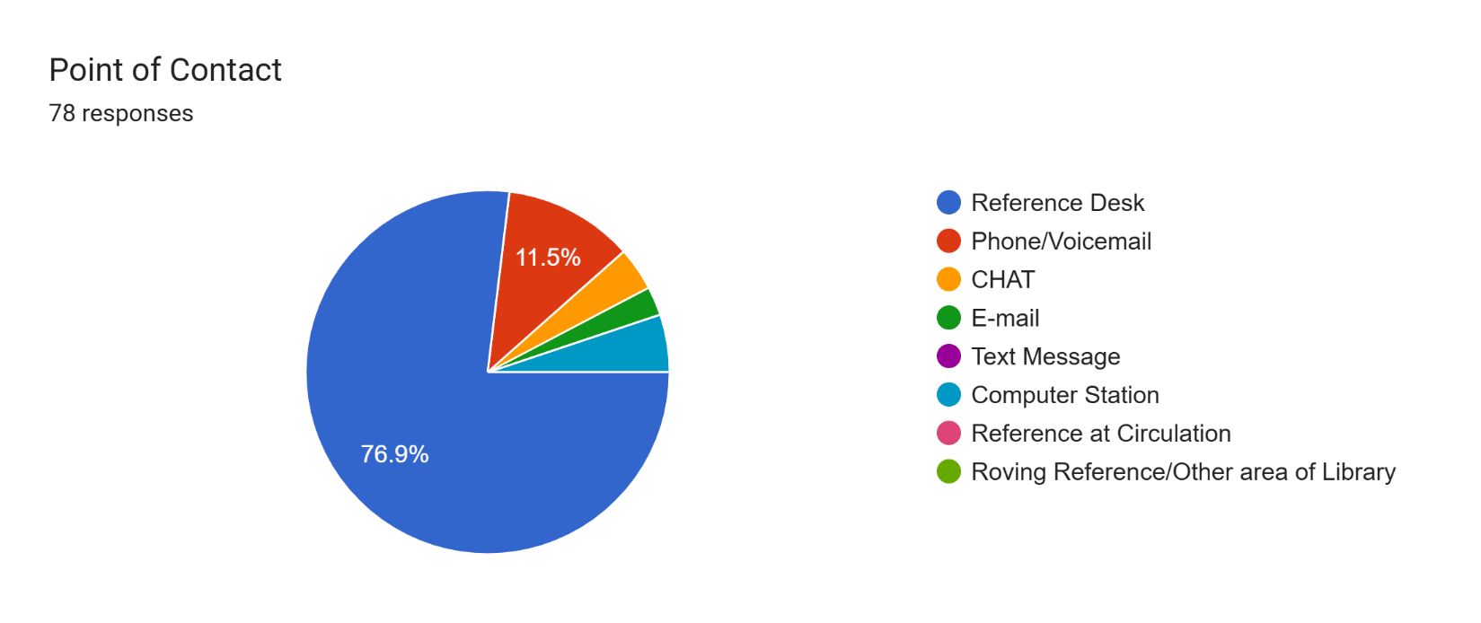

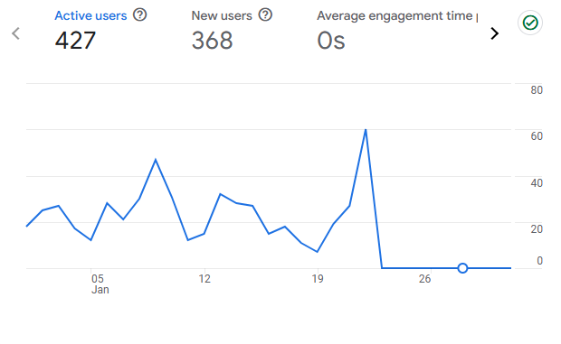

**Youth Services Report**

**Children’s Department**

January programs for children and families included Storytimes and Babytime. All were well attended. Picatinny Kindergarten returned in January for a Storytime and craft. The children attended Move & Groove with Miss Jolie. Hibernia continues to offer weekly crafts for children. For grades 4-6, we offered an Anime Drawing class. Cody and his owner visited for Read to a Dog for children.

Later in February, we have scheduled a Pokemon Trading Club where parents and their child (ages 6-11) can trade cards with parent approval. The children will also be able to bring in their collections and discuss Pokemon with other children. Based upon our discussions with colleagues in other libraries Pokemon seems to be most popular with children 6-11. If we find we are getting requests for Pokemon for older children we will accommodate that age group as well.

**Teens**

We are in contact with the Red Cross to schedule a babysitting program for teens 11-15 years old and expect to have a workshop in the late winter- early spring.

We are looking into the new procedures for obtaining working papers for teens to develop either a program, resource list, or link that teens may access.

Teen Volunteers are coming in each week to weed in childrens and teens, clean toys and make bookmarks. Volunteering continues so that the teens can fulfill their community service requirements.

Darlene Steinhart

Head of Youth Services

**Foundation Report**

The Foundation is pleased to report that to date, approximately $13,000 has been raised as a result of the Annual Appeal, and donations continue to come in. Dates are out for the next meeting to be scheduled. The Appeal will continue to be promoted.

**Old Business**

**Bathroom Renovation Committee** Laurie and JoAnn volunteered to join the committee along with Scott. Meetings will be scheduled at which the three proposals will be reviewed; architects will be vetted; Township protocols for bids will be followed; and design ideas for colors and materials proposed.

**Teen and Community Outreach/Programming** The Board discussed the American Red Cross Babysitting program cost ($1,123 for 8 teens) and agreed it was justified in order to bring teens into the library. The refundable $50 deposit would be to ensure that the participants were committed to attending. The Board discussed reaching out to Girl Scout Troops, Boy Scout Troops, RTPS schools, especially Copeland Middle School, and private schools to promote this certification opportunity. Scott will find out if there is a cap on attendees. If the program is successful, we can replicate it and/or add the CPR certification in the next round.

Another outreach idea was to have a tent at the Spring Festival where patrons could donate to the food pantry. Emily mentioned that diapers and other baby care items are also in demand.

Marie suggested that teens would respond favorably to a service group that meets at the library. She said that in her experience as a middle school librarian, youth respond positively to calls for help in the community. The Board will look to implement this idea.

JoAnn suggested painting the front windows seasonally or for holidays might be a fun way to encourage teens to participate.

The Working Papers for Teens information workshop idea is well received. We can reach interested teens through an email blast, social media contacts, the RT Library Newsletter, signage in the RT Library, and outreach with our regional high school system.

**Notary** The Board discussednotary services and agreed they should be offered free of charge as the notary services are in the Municipal Building.

**New Business**

**Negotiations Committee** Scott shared that the Union has reached out to begin contract negotiations. Ray, Laurie, and Marie volunteered to serve on this committee.

**NJ Library Trustee Association Membership** Scott and Marie brought up membership in the Association. There is a wealth of useful information and guidance available to Trustee members. The library can pay for all of the Trustees to join at a cost of $20 each. It was agreed that we would email Scott our information and he would apply for us.

**Tonie Player Borrowing Agreement**  Scott showed the Board how the Tonie players work, and the agreement was reviewed. Laurie suggested that the late fee be raised to $5 instead of $2, and that the spelling of Tonie be consistent throughout the document. Marie made a motion to approve the Tonie Player Borrowing Agreement as amended; Ray seconded. Motion approved.

**Public Portion of the Meeting**: Isabelle suggested that the Historical Society be contacted before making the video for the grant application. There are of photos of local patrons getting married and participating in other ceremonies in the Hibernia Church, and residents who could speak about the history. Perhaps reaching out to Trinity Church for more information would be helpful. She also suggested that the Tonies be offered first to Township residents. Scott will list them as New Items so they will be.

**Board Comments**

* Ray has a connection with a filmmaker and will reach out to see if they can help us produce the grant video.
* Laurie asked if the Superintendent of Schools was preparing for the challenges meeting student needs that would result should the current federal administration dismantle the United States Department of Education. Marie responded that Dr. Corbett is monitoring the situation along with the Board of Education, and will take appropriate action to meet the needs of all students in our District.
* JoAnn asked about the funding formula and the forthcoming budget. Scott explained that it is 1/3 of 1 millionth of 1% for our funding.
* JoAnn said that she is grateful for Marie’s strong leadership. She said it is a pleasure to be a part of such a productive and efficient body as our Board.
* The Board again thanks the Friends for all their hard work on behalf of RTPL and encourages everyone to register for Millionaire Trivia on February 28 at 7:00!

**Adjournment** Motion to adjourn made by Marie; seconded by JoAnn. Motion carried. Meeting adjourned at 7:32 pm.

**Date of Next Meeting:** Monday, March 17 at 6:30 pm

Respectfully submitted,

*Bronwyn Springer*

Secretary