The meeting was called to order at 6:37 pm by Board President, Marie Onorevole.

**Sunshine Statement**: This meeting has been posted in accordance with the Open Public Meetings Act, in the officially designated newspapers and The Library.

**Roll Call:**

* Marie Onorevole, President and Alternate to the Superintendent
* Ray Furman, Treasurer
* Bronwyn Springer, Secretary
* Carol Tauber, Trustee at Large (via Zoom)
* JoAnn Claps, Alternate to the Mayor
* Emanuel Friedlander, Council Liaison
* Scott Davan, Library Director

**Absent:** Laurie Schorno, Vice President, Emily Kullmann, Trustee at Large

**Also Present:** no members of the public in attendance

**Agenda Approval:** revised agenda approved as written.

**Approval of Minutes:** Motion to approve February minutes made by Marie; seconded by JoAnn. Motion carried.

**Treasurer’s Report:** Motion to approve bills accrued in March in the amount of $55,444.16 made by Ray; seconded by Bronwyn. Motion carried.

**President’s Report**

**From the Schools:**

1. The Wizard of Oz (Youth Edition)

The Copeland Middle School performance is scheduled for this week.

Thursday, March 20-7 PM

Friday, March 21- 7 PM

Saturday, March 22- 2 PM

Tickets:

Adults $10

Students/Seniors $5

<https://www.rocktwp.net/article/2083165>

1. RTSD Referendum News Items/Updates

Please refer to the link below for updates on the status of the referendum. The information provided includes proposed changes in all 6 schools, maintaining facilities to meet the needs of the 21st Century.

<https://www.rocktwp.net/o/rockaway/page/referendum>

1. Gearing up for Kindergarten Registration for 2025- 2026 School Year

Registration forms and information about registration can be found using the link below.

<https://www.rocktwp.net/article/1437407>

**For the Board:**

1. The mural is beautiful and has transformed a non-descript staircase into a lush landscape of Rockaway Township beauty! The feedback has been glowing. The Board acknowledges Emily Kullman’s recommendation to a gifted graffiti artist, Carmello! Her vision for creating a beautiful space within our Library that was previously overlooked, is greatly appreciated!
2. We are moving along in a timely manner with the Historic Preservation Grant. The Letter of Intent was filed on time and the completed application due the end of March is on track to be submitted. Scott, Bronwyn, and Christy Williams (the grant writer) are working diligently to oversee the process.
3. There are several policies being developed that deal with new services and/or programs we are adding to the Library’s offerings. Notary Service/Notary Policy and the Art Exhibit Policy are among them. More information will be provided for discussion going forward.

**For the Staff:**

Every month brings exciting new programming, activities, and services for the residents of Rockaway Township. None of this would be possible without the dedication and talent of our staff! Thank you for all that you bring to the table each and every day!

**Director's Report**

**Spring Festival**

Planning is progressing on the Spring Festival. Presently we have the following attractions confirmed: face painter, balloon twister, stilt walker, Bluey & Sonic meet and greets, bouncy slide, rock wall, 2 mobile escape rooms, gaming truck, petting zoo, touch a truck (Police, Fire, DPW?) and 4 potentially 5 food trucks: Mr. Sam’s Ice Cream Truck, Cousins Maine Lobster, The Empanada Guy, Screams Pizza Truck, and potentially TaxiCab Burgers.

***Wizard of Oz* Story Time**

As we continue pushing forward with our goal of increased collaboration with the School District, we were able to get the principal cast of Copeland Middle School’s Production of the *Wizard of Oz* to attend our Tuesday morning Story time. The cast came dressed in costume, sang songs, and interacted with the children. It was an excellent collaboration with the schools.

**Notary**We are still on target to roll out Notary Services in the next few months. Lisa Laskaris has completed her program and is officially a Notary, Rachel Franklin as well. I’ll be looking into the need for Notary insurance as well as further discuss our policy before rolling out the service.

**Mural**

I’m thrilled to announce that our stairwell mural is complete and it’s beautiful. It has been well received with the only criticism being that it makes the hallway feel a bit dark. We’ll investigate the potential to add some additional lights. Please take a look at it if you have not.

**Pokémon Trading Club**

In our renewed efforts to increase teen programming we held our first Pokémon Trading Club meeting last month and it was successful in that over 20 patrons attended; however, the average age was estimated at 10 years old. We’ll both continue the Pokémon Club as well as push forward with additional programming for teens.

**Red Cross Babysitting Training**

We’ve had to reschedule the Red Cross Babysitting Training course due to limited signups. Of the 8 needed to host the training only 2 signed up officially. This was rather surprising due to the expected demand from a staff member who is very involved in Girl Scouts. The feedback we received was to reschedule in the summer when the teens are more available. We’re currently in talks with the Red Cross to select a new date.

**Hibernia Update**

During our last major rain event we were experiencing significant leaking inside where the vestibule meets the main building. The Township has been made aware of the issue and so has Margaret Hickey of Connolly & Hickey our Historic Architect.   
  
We are progressing on the grant to go after the update to our Preservation Plan while simultaneously working with the Township to explore the possibility of painting the building directly. If the painting can progress without impacting on the Preservation Plan, then I’ll continue to explore the possibility as it could theoretically slingshot us forward in repairs and restoration by 2 years.

**Trustee Association**

Thank you to everyone who has responded with their contact information for the Trustee Association. The membership application will be mailed soon, and the Association will contact you when completed.

**NJLA & ALA Annual Conferences**

The dates for both NJLA and ALA (Philadelphia) have been announced. I’ve notified our Librarians and am working with staff to arrange coverage. The ALA conference has not been in our area for some time and I’m excited to attend it for the very first time. Additionally, MAIN is offering $500 stipends to libraries that send staff to ALA to help defer costs.

**English Conversation Classes**

As previously discussed, I’ve been working with LVA (Literacy Volunteers of America) to begin English Conversation Classes or group ELL classes at the library. I’m pleased to announce that we will soon be advertising for our first class scheduled for Thursday, April 15th. We’re hoping to hold this meeting on the third Thursday of every month, and I’ll report back with an update.

**Reminder**

As previously approved, the Library will be closed in the morning on Thursday, March 20 for training.

**Donation**

Katherine D. Malone School has graciously donated a quilt to the library. Thank you to the students, families and staff of KDM!

Our Next Meeting is Scheduled for Monday, April 21st.

**Department Reports**

**Adult Services Report**

From: Lisa Laskaris Reference / IT Librarian

* Reference / Adult Services
  + We answered 130 reference questions in February.
  + We continued reference virtual and in person services through February 2025, along with continued services to the public (browsing, studying, groups meeting, computer time) chat, Facebook, Kanopy, Libby for access of eBooks, audiobooks, movies, magazines. We have Libby for digital magazines and newspapers. We staffed the online chat for our open hours Monday-Thursday 9:00am-8:00pm and Tuesday, Friday-Saturday 9:00am-5:00pm, Sunday 1:00pm-4:00pm, checking and responding to patron phone calls, emails, chats and texts.
  + Continuing to develop and book new in-person and virtual programs for upcoming months.
  + We booked Meeting Room requests for the upcoming months.
  + We sent out our monthly newsletter and book club newsletters.
  + Our book club met in February and had 8 people attend.
  + Movies: You Gotta Believe – 8 attended.
* Programming
  + Adult services February programs:
    - MAIN-wide Virtual African American Art in NYC – 5 RTPL signed up, 51 attended MAIN wide!
    - MAIN-wide Virtual Emergency Preparedness – 21 RTPL signed up, 143 attended MAIN wide!
    - History of St. Valentines – 7 signed up! 6 attended!
    - Crystal Sound Bowl Meditation – 15 signed up, 12 attended (15 max)!
    - (Local NJ) Virtual Civil War Round Table – 5 RTPL signed up, 90 attended total!
    - MAIN-wide – Virtual Dutch Paintings – 8 RTPL singed up, 200 attended MAIN wide!
* Information Technology
  + Gmail conversion complete from JerseyConnect. Staff has all logged in. We are moving forward using more of the Google Workspace features for the future.
  + Attended Koha training for upcoming ILS change.
  + Working details for Star Ledger readers (in print stopped February 3rd).
  + Helped patrons with tech issues one-on-one, private classes.
  + Buying weekly eBooks and eAudiobooks from Libby/Overdrive.

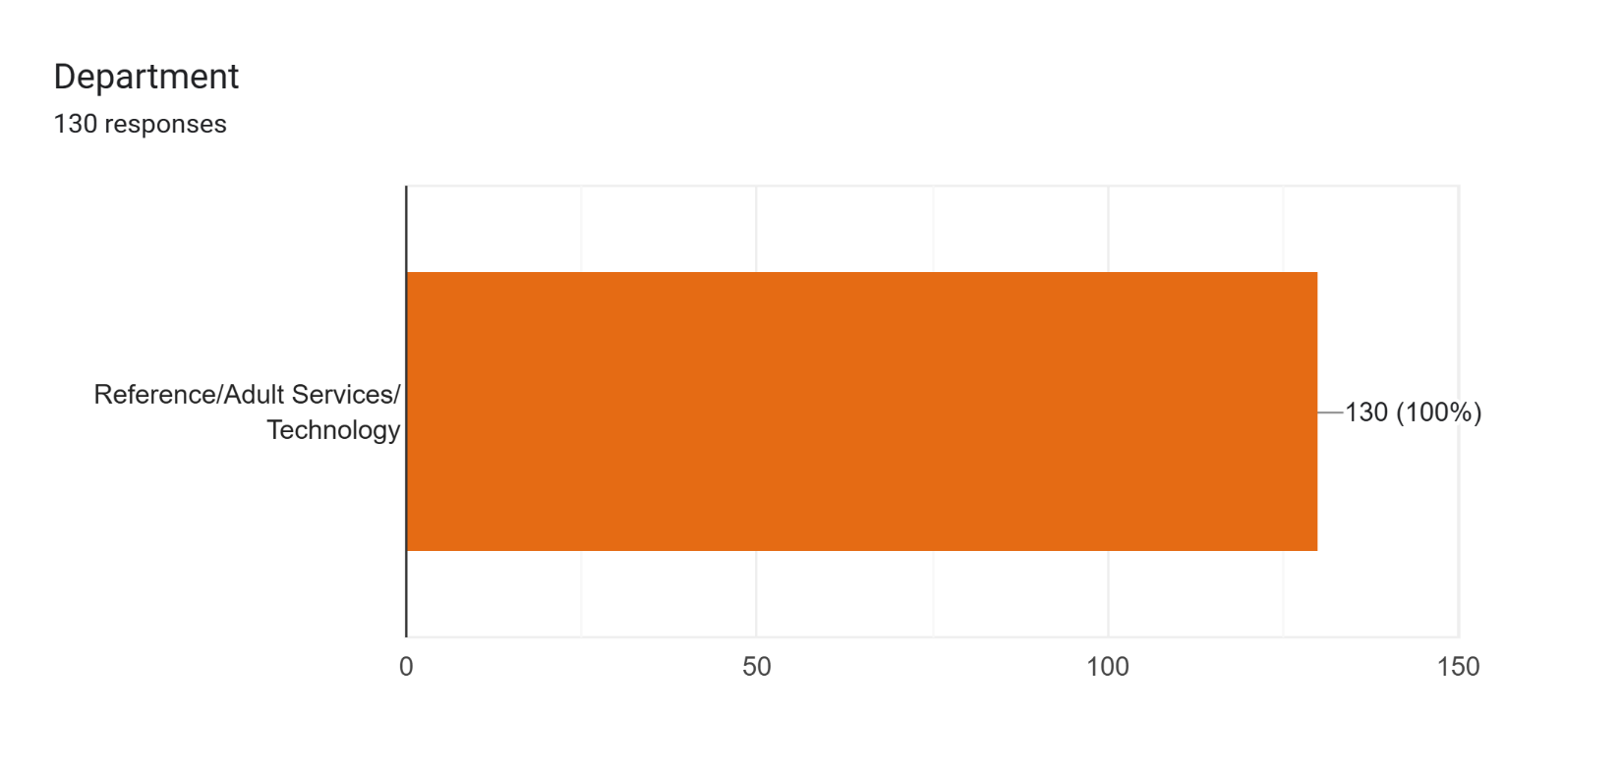

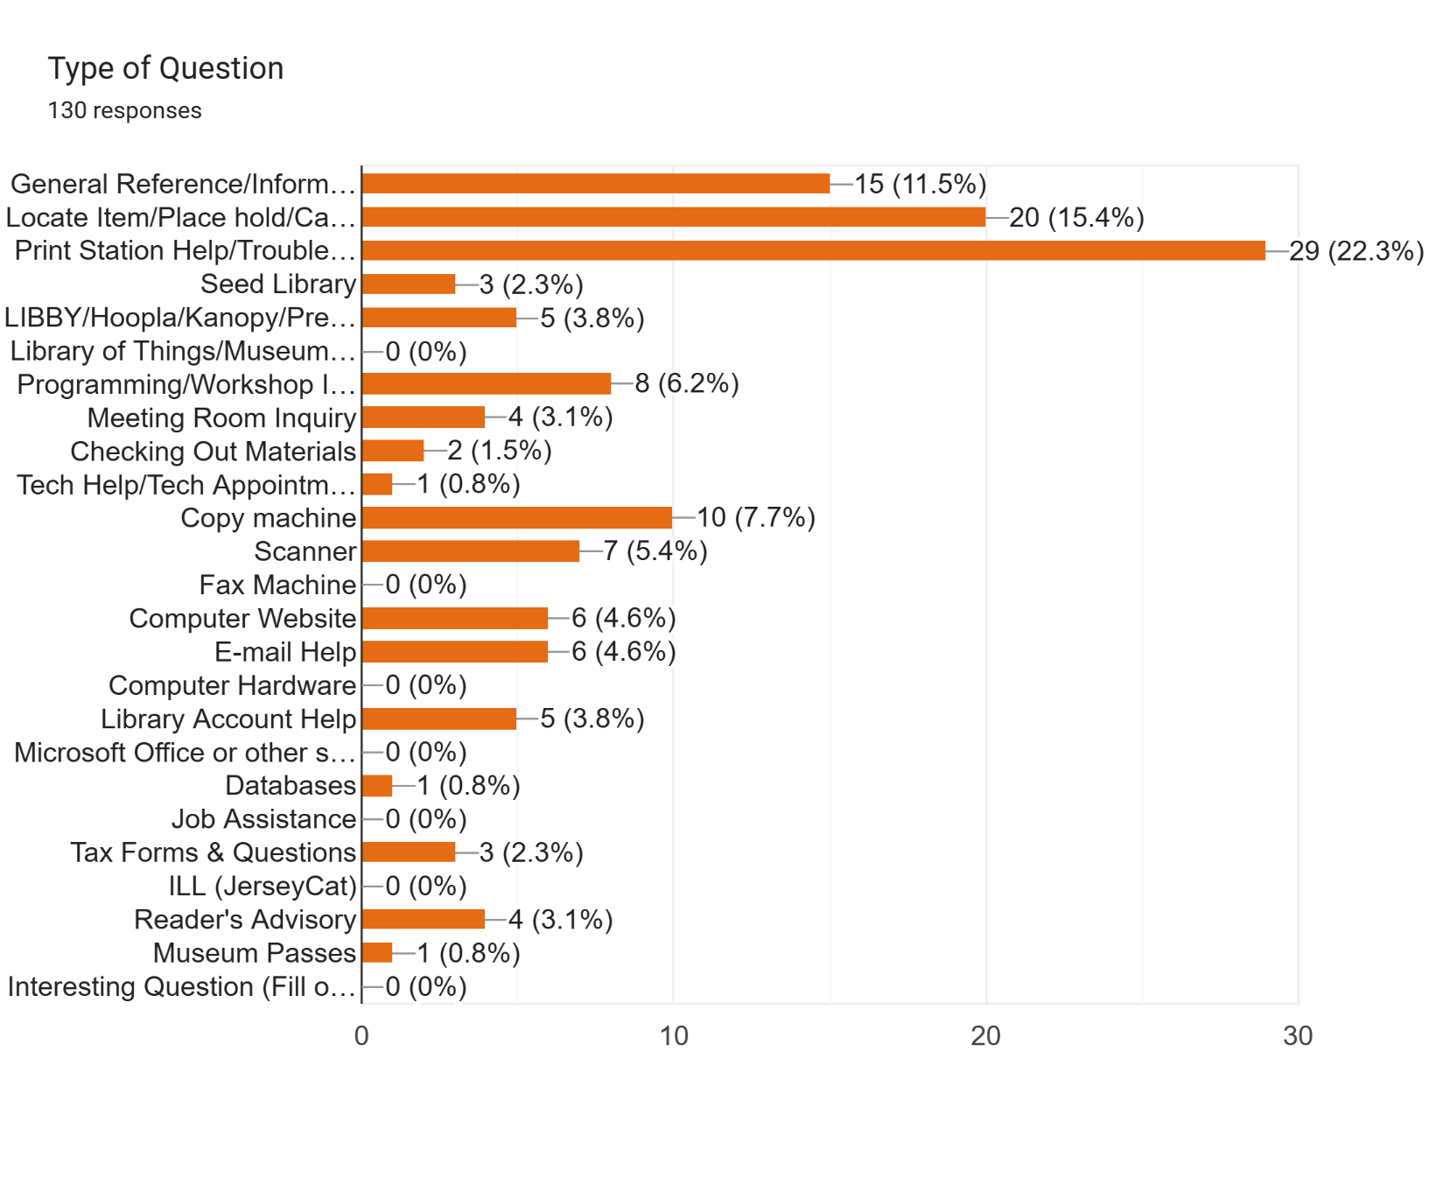

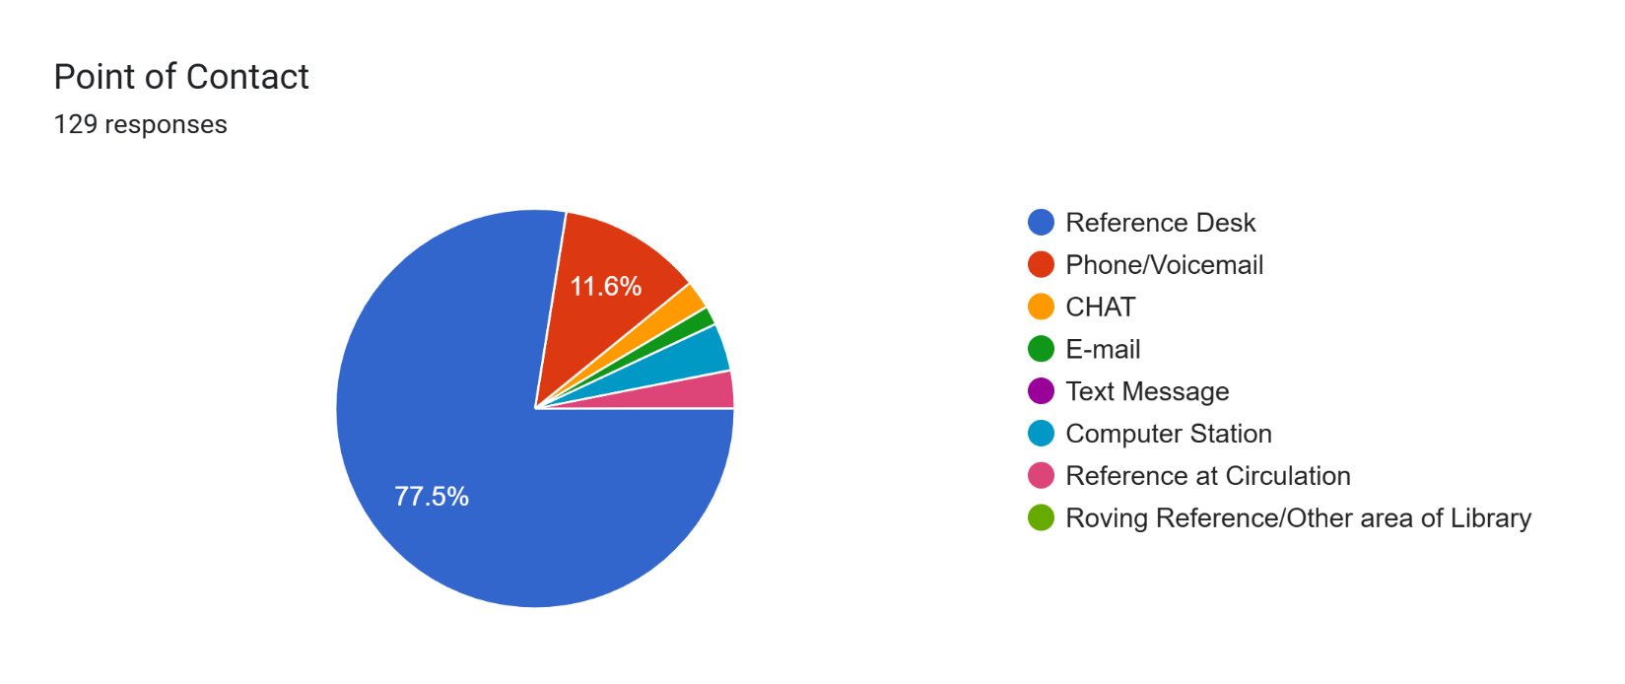

**Youth Services Report**

**Children’s Department**

February programs for children and families included Storytime, Babytime, Move & Groove with Miss Jolie, Play-Doh playtime, Busy Builders, and Family Crafternoon. All were well attended.

As a special treat, the Copeland School cast of *Wizard of Oz* performed at and participated in Storytime this past week. How to Draw Anime with Leah for grades 4-8 was popular. Our first Pokémon Trading Club for ages 6-11 was so successful that we are repeating it monthly. Leah Abrams will add more Pokémon programs including drawing, trading card making, and trivia.

Picatinny Kindergarten returned in February for a Storytime and craft. Hibernia continues to offer weekly crafts for children. Cody and his owner visited for Read to a Dog for children.

**Teens**

We scheduled a babysitting program offered by the Red Cross for teens 11-15 years old for a Saturday in mid-March but canceled due to lack of interest. Feedback indicated that a different time of year may be more popular. We will be rescheduling the program for some time during the week in the summer.

We linked the government website for working papers for teens to our teen resource page. The website is straightforward and a teen must have a job offer before creating and account to receive working papers.

Teen volunteers are coming in each week to weed in children’s and teens, clean toys and make bookmarks. Volunteering continues so that the teens can fulfill their community service requirements.

Darlene Steinhart

Head of Youth Services

**Foundation Report**

The Foundation will next meet on Monday, March 24th at 6:30.

**Old Business**

**2025 Budget**

Following Board review, Marie made a motion to approve the 2025 Budget. Bronwyn seconded. Motion approved.

**Notary Services**

The Board discussed whether or not to charge for notary services. Ray felt it was appropriate to charge a nominal fee. Marie felt services should be free for residents. The library paid to get librarians certified as notaries and will have to pay to insure them. Given that we are open late and on weekends when other agencies might not be available, it makes sense to charge a small fee.

It was agreed to make the service free to residents for the first notarization. Non-residents and subsequent service for residents would cost $1.00. Outlining what can and can’t be notarized and encouraging patrons to call ahead to make an appointment should be included in the document as well. A draft of the notary policy will be brought to the April meeting for review.

**American Red Cross Babysitting Certification**

The Board was surprised by the lack of interest in this program. Feedback was that the timing was not good – a summer program would be better. No one took issue with the deposit. We will try again in June and will be sure to broaden outreach via social media, school backpacks-especially at Copeland, and to other constituencies such as Scouts.

**Resolution for Connolly & Hickey for Architectural Services**

Scott explained: the cost of $32,700 for design and development; the fact that we have the funds in our budget; that 80% will be reimbursed to us; that the Township has to apply; and that Business Administrator Lisa Palmieri has assured him that we can move forward given that the Library is paying.

The Board reviewed the resolution document. Ray made a motion that the Resolution for Connolly & Hickey Architectural Services be approved with minor typographical errors corrected. Marie seconded. Motion approved.

**New Business**

**Inclement Weather Policy**

The Board reviewed and discussed this policy. Concerns expressed by a board member submitted in writing were included in the discussion. It was agreed that the decision to close should be made after consulting all constituencies as outlined in the policy document. Ray made a motion to accept the Inclement Weather Policy. Second by JoAnn. Motion approved.

**Institute of Museum and Library Services**

Scott shared news that had just broken prior to the meeting regarding the Trump administration’s directive to dismantle the Institute of Museum and Library Services, or IMLS, which funds critical library services nationwide. For RTFPL, $10,500 in direct funding would be lost.

In NJ, funding for vital programs would be cut, including Summer Reading, Jersey Connect (technology services and network infrastructure helping bridge the digital divide and providing low-cost internet access to public libraries in NJ), JerseyClicks (databases that benefit college and K-12 students), along with statewide resource sharing, services for people with disabilities, professional development for trustees, and our State Library, to name just a few.

The American Library Association (ALA) is sounding the alarm about how this executive order will harm people who rely on our public libraries.

To learn more about issues surrounding funding and what the public and libraries can do to help:

https://ilovelibraries.org/article/trump-administration-calls-for-elimination-of-federal-funding-for-libraries/

**Art Exhibition Policy**

Marie suggested that this discussion be tabled until next month’s meeting and the Board agreed.

**Public Portion of the Meeting**: No members of the public present

**Closed Session – Discussion of Union Negotiations**

Marie made a motion to move into closed session to discuss the union negotiations. JoAnn seconded. Motion approved.

Marie made a motion to come out of closed session. JoAnn seconded. Motion approved.

The Board will make the minutes available after negotiations are complete.

**Board Comments**

* Ray reminded the Board about the Morris County Passport Outreach Event held at our RT Municipal Building on Tuesday, June 17 from 10-2:00
* Manny stated he is proud of the fact that we are one of the 47 libraries in NJ who have adopted policy declaring our library a book sanctuary, thereby resisting book bans
* Bronwyn wanted to be sure that the fliers for the LVA’s ESL classes would go to Dwyer and Copeland schools specifically

**Adjournment** Motion to adjourn made by Marie; seconded by Ray. Motion carried. Meeting adjourned at 8:27 pm.

**Date of Next Meeting:** Monday, April 21 at 6:30 pm

Respectfully submitted,

*Bronwyn Springer*

Secretary