The meeting was called to order at 6:33 pm by Board President, Marie Onorevole.

**Sunshine Statement**: This meeting has been posted in accordance with the Open Public Meetings Act, in the officially designated newspapers and The Library.

**Roll Call:**

* Marie Onorevole, President and Alternate to the Superintendent
* Ray Furman, Treasurer
* Bronwyn Springer, Secretary
* Emily Kullmann, Trustee at Large (via telephone)
* Carol Tauber, Trustee at Large
* JoAnn Claps, Alternate to the Mayor
* Emanuel Friedlander, Council Liaison
* Scott Davan, Library Director

**Absent:**  Laurie Schorno, Vice President

**Also Present:** Isabelle Avigliano

**Agenda Approval:**  Agenda approved as written

**Approval of Minutes:** Motion to approve May minutes made by Marie; seconded by Ray. Motion carried.

**Treasurer’s Report:** Motion to approve bills accrued in May in the amount of $34,145.27 made by Ray; seconded by Bronwyn. Motion carried.

**President’s Report**

**From the Schools:**

1. Copeland Middle School Graduation: scheduled for June 18th at 5 PM, at Morris Knolls High School. The ceremony will be Live Stream using the link below.

<https://www.rocktwp.net/article/1153650>

1. District Goals and Strategic Plan Annual Update: June 11, 2025

Use the link below to access this document.

<https://www.rocktwp.net/article/2266787>

**To the Board:**

1. On June 9th, Scott, Bronwyn, Margaret Hickey (our Historical Architect), and I attended the Final Presentation for the Morris County Historic Presentation Trust Fund, at the Schuyler Conference Room, 30 Schuyler Place, Morristown. Scott presented a 7-minute PowerPoint of our application and historical perspective of the Hibernia Branch. The presentation was well received. Announcements of Grant awards will be in the near future.
2. Art Exhibit Policy and Art Exhibit Waiver/Application will be presented in draft for discussion tonight. Trustees can provide input at this time. Hopefully, this policy will be in place before fall so exhibits of community and student talents can be scheduled.

**To the Staff**

On my frequent visits to our Library, I am always struck by the friendliness and professionalism displayed by our staff to everyone. The patrons receive a smile, greeting of welcome, and gracious service. I have also witnessed situations when these interactions are not easy for the staff, but the response is always the same- patient and courteous. I also notice and appreciate the seasonal decorations and book displays that add an extra spark to our beautiful Library.

Thank you for all that you do! It does not go unnoticed!

**Director's Report**

**MAIN Standardization of Loan Periods**

At the June Membership meeting the majority of members voted to implement a MAIN wide set of circulation standards of materials; see attached. I, along with a few others, voted against this measure as it both limits the individual freedom of a member library to set policy, reduces control over materials purchased by the owning library, and generally erodes the independence of libraries to operate in the best interest of their home town. I’m extremely discouraged at the continued erosion of independence within MAIN.

**Dumpster**

I’ve gotten quote for a dumpster and am looking to move forward with ordering it very soon.

**HVAC System**

As you may recall, we’ve been dealing with a multitude of HVAC issues this past winter and it seems after all the visits from Reiner, Tom Marquet, our HVAC software consultant, discovered the issue. Over the course of the winter the upper level was consistently cooler than it was set for. Reiner came out multiple times and blamed the

issue on the software and would leave. Turns out there was trapped air in the hot water lines for the recirculation system which was discovered when Mr. Marquet reviewed the pressure gauges on either side of the circulation pumps. Reiner insisted the issue was on the software side, but after some contentious back and forth with the technician, he finally acquiesced and bled the air from the lines. Since then, we’ve made significant improvement.

**Grant Presentation**

We presented our final grant presentation to the Historic Commission on Monday, June 9th. The presentation went very well and we feel very confident our application will be approved. I’ll let everyone know as soon as we hear.

**New Employee**

We’ve hired a new Part Time Library Assistant. His name is Derek Grayson, please say hello and introduce yourself when you have a chance.

**Delivery Task Force**

The Delivery Task Force held another meeting on June 3rd. Thankfully it appears there won’t be much to do as LibraryLinkNJ is forecasting a 10% increase in cost share which equates to $110 for us. We did however discuss the potential of LibraryLinkNJ’s budget failing and the steps needed to proceed if catastrophe strikes.

**Voter Registration**

A voter registration information station has been created as requested. A sign has been posted and printed applications in English and Spanish are available near the television on the upper floor.

**Pride Display Reaction**

Someone checked, created a video of some of the books in our Pride Month display, and posted a video on YouTube which was then shared on Facebook causing an intense discussion online between residents. In all the uproar that was created online, not one single comment, complaint, or inquiry was received by the Library. I’m grateful to see that many of residents of Rockaway came to our support.

**Passport Day**

Pop-up Passport Day has arrived. Tuesday, June 17th we’ll be hosting the county’s Passport Day. Patrons can come in on a first come first serve basis between 10am-2pm to get their passport applications processed by the County Clerk’s office. We’ll be hosting this in our meeting room and will use the turnout as a gauge for future discussion on becoming a passport processing center.

**Verizon Upgrade to the phone lines**On Monday, June 23rd the Verizon will be upgrading our phone lines as part of their infrastructure upgrade plan of swapping copper lines for fiber optic. I don’t know for certain at this moment but I’m confident we’ll be without phones for a portion of the day.

**Heading to ALA on Saturday, June 29th**

I’ll be heading to the ALA National Convention in Philadelphia on Saturday, June 29th. This will be the first time I’ve attended ALA and I’m very much looking forward to it.

Next meeting is on Monday, July 21st at 6:30pm.

**Department Reports**

**Adult Services Report**

From: Lisa Laskaris Reference / IT Librarian

* Reference / Adult Services
  + We answered 204 reference questions in May.
  + We continued reference virtual and in person services through May 2025, along with continued services to the public (browsing, studying, groups meeting, computer time) chat, Facebook, Kanopy, Libby for access of ebooks, audiobooks, movies, magazines. We have Libby for digital magazines and newspapers. We staffed the online chat for our open hours Monday-Thursday 9:00am-8:00pm and Tuesday, Friday-Saturday 9:00am-5:00pm, checking and responding to patron phone calls, emails, chats and texts.
  + Continuing to develop and book new in-person and virtual programs for upcoming months.
  + We booked Meeting Room requests for the upcoming months.
  + We sent out our monthly newsletter and book club newsletters.
  + Our book club met in May and had 8 people attend.
  + Our seed library is going strong. I updated the catalog book of seeds.
  + Movies:
    - Cabrini May 1st – 14 attended
    - Conclave May 15th – 25 attended
* Programming
  + Adult services March programs:
    - Virtual MAIN Romanticism – 5 signed up
    - Virtual MAIN-Caspar Frederich – 1 signed up, 52 attended main-wide
    - Virtual MAIN Author Talk John Blake – 2 signed up, but the program was not held
    - Virtual Civil War Round Table – 3 RTPL signed up
* Information Technology
  + Helped patrons with tech issues one-on-one, private classes.
  + Buying weekly ebooks and eaudiobooks from Libby/Overdrive.

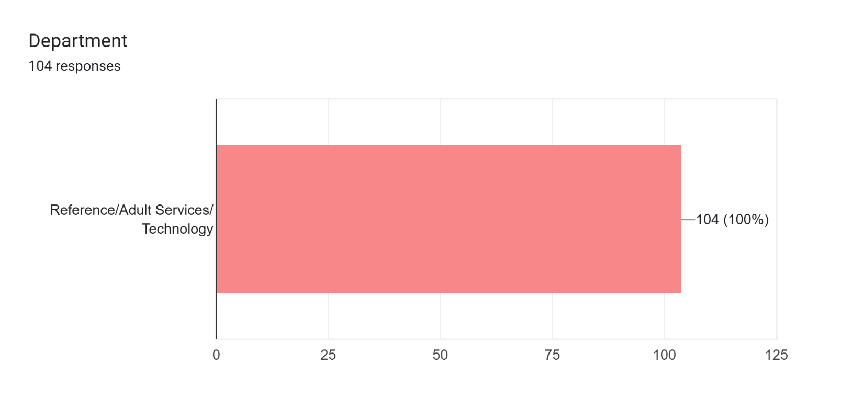

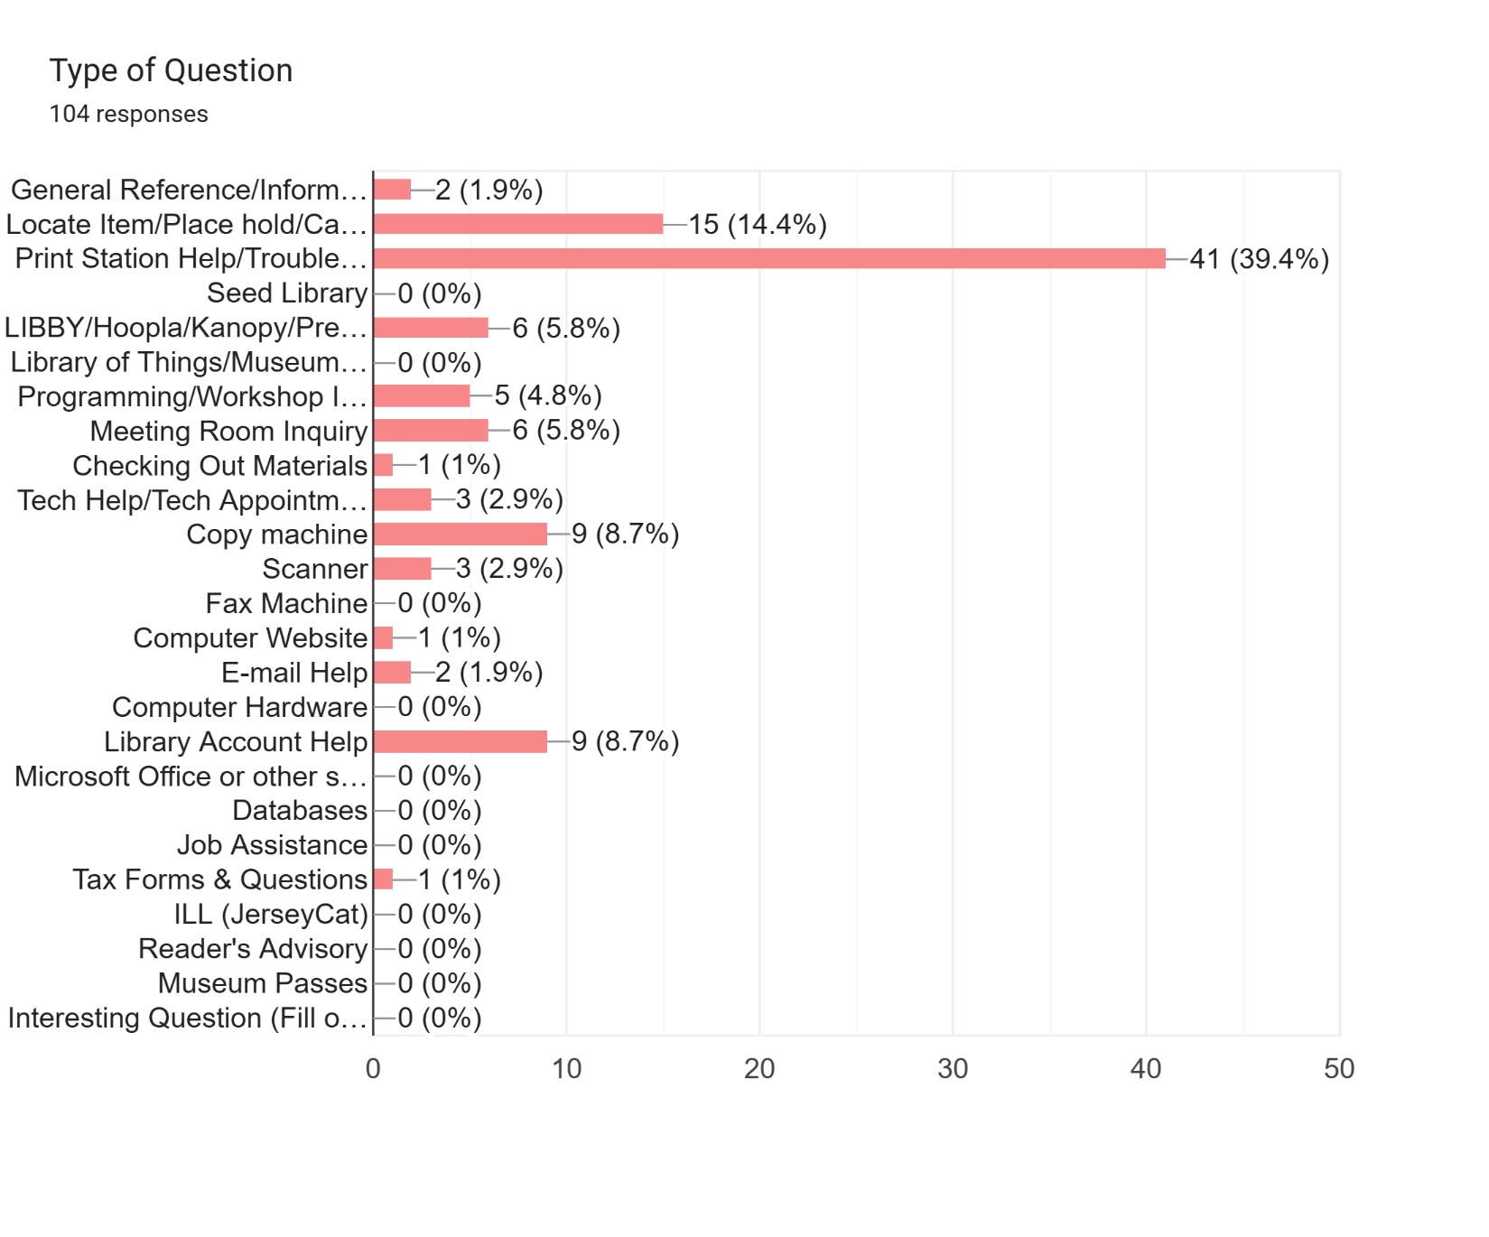

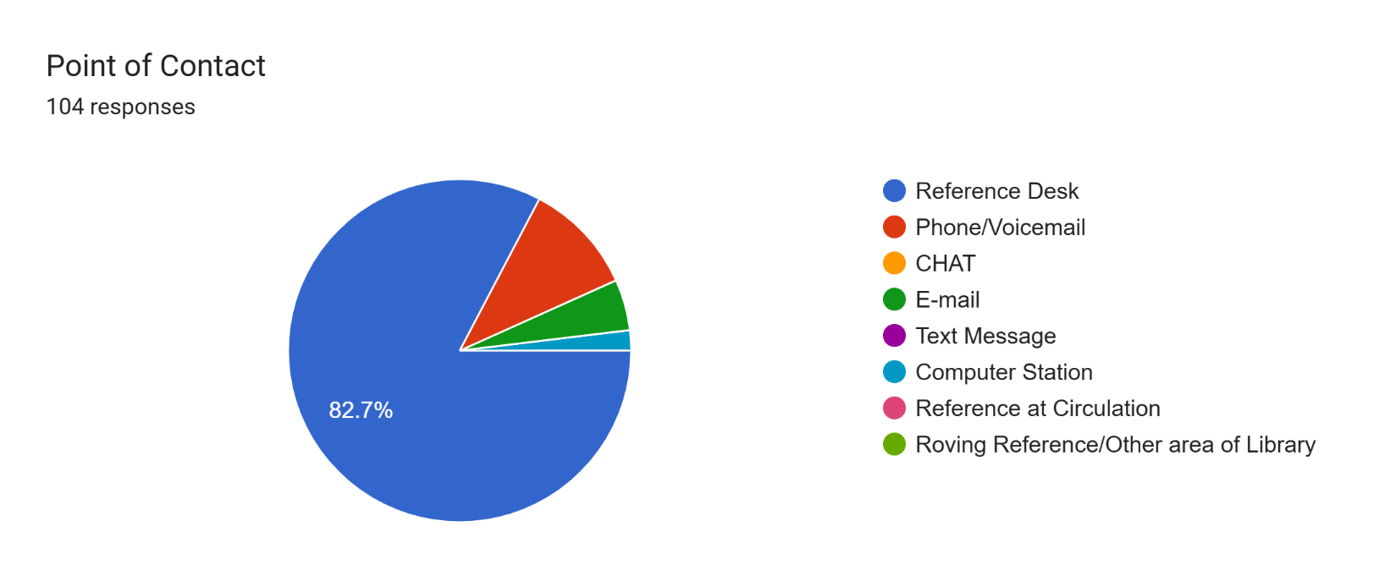

**Youth Services Report**

**Children’s Department**

May programs for children and families included Storytime, Babytime, Move & Groove with Miss Jolie, Busy Builders, and Pokemon Trading Club. All were well attended.

Picatinny Kindergarten returned in May for a Storytime and craft. Hibernia continues to offer weekly crafts for children. Cody and his owner visited for Read to a Dog for children.

Summer reading will include Storytimes and performers such as Conrad the Magician, Miss Jolie, Leah doing drawing programs, and Peas & Carrots in addition to many others.

**Teens**

Our summer teen programs will include drawing programs with Leah, Take home tie dye, and the American Red Cross Babysitter course with CPR. We also have a summer reading program with weekly prizes.

Teen summer volunteer applications are available in the library, at Copeland School and online. We are now receiving applications for summer volunteering so that the teens can fulfill their community service requirements.

Darlene Steinhart, Head of Youth Services

**Foundation Report**

The Foundation has no report this month.

**Old Business**

**Bathroom Renovation Committee**

Scott will forward the link to one of the proposed architect’s websites. The committee will meet to review the bids. We are hoping to award the bid at the July meeting.

**New Business**

**Art Display Policy**

The Board reviewed and discussed the proposed Display Policy, including: whether we want to specify the exhibit spaces (meeting room/upstairs display cases); issues around sales; language regarding publicity; and who will be responsible for reviewing the application to exhibit requests. The policy document will be revised following these discussions and brought back next month for final review and a vote on adoption.

**Public Portion of the Meeting**: Isabelle asked if there would be automatic faucets in the new bathrooms and Scott responded that we are looking for full automation. Also, the lights will be repositioned and a changing table added in the men’s room.

**Board Comments**

* Carol recommended the Board read an article from the *Wall Street Journal* about author Jennifer A. Nielsen, who writes historical novels featuring teenage female protagonists (Uprising, One Wrong Step) and Alan Gratz, who writes historical fiction that appeals to teen boys (Heroes, Code of Honor). Popular among the middle school demographic, the authors are engaged in a nationwide tour discussing their works. Carol passed the information on to Scott who will look into the opportunity.
* Bronwyn had a conversation with a patron who suggested we add a puzzle table, perhaps near the fireplace/TV in Main. These community puzzle tables are a great way to build engagement.
* Ray suggested we grow our collection of books in languages other than English, particularly in the Children’s area. She brought up the possibility of virtual author talks through the Horizon Speakers Bureau. In addition, Ray had completed the online New Jersey Library Trustees Association (NJLTA) survey, and was invited to participate in an in-depth focus group. She encouraged the Board to take advantage of the offerings available from the NJLTA. Ray also had a reference for a plumber should we need to switch in future.
* Marie asked about muralist Carmelo Sigona painting a companion piece to the hallway mural on the blank column/wall behind the reference desk. Scott said Emily had spoken with Carmelo who said he could create a mural in the area for $700 approximately. The Board plans to dedicate Carmelo’s hallway mural at the July meeting, and will discuss this idea further.

**Adjournment** Motion to adjourn made by Marie; seconded by Ray. Motion carried. Meeting adjourned at 7:50 pm.

**Date of Next Meeting:** Monday, July 21 at 6:30 pm

Respectfully submitted,

*Bronwyn Springer*

Secretary